**SOURCE MONİTOR**

**KİVİYAT GRAFİĞİ**

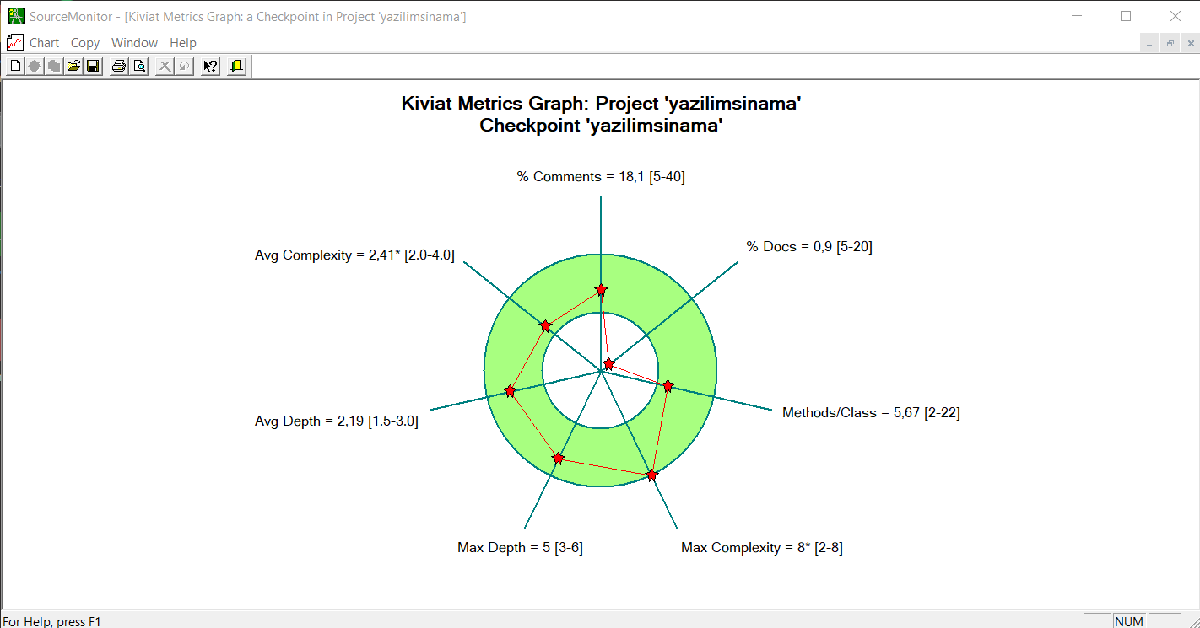

**BLOCK HİSTOGRAM**

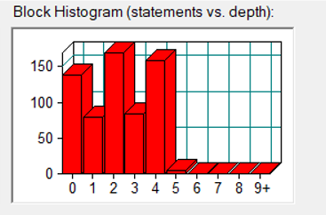

**GİTHUB LİNKİ:**

<https://github.com/muratakcy/MCBENCRYPTO_Mesaj_Sifreleme_Sistemi>